##### ****(North-East India)****

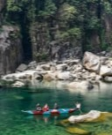

#### ****Meghalaya****

##### Scotland of East



#### ****Nagaland****

##### Go to Kohima, visit the Hornbill Festival and camp at Dzuko Valley

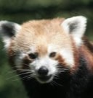

#### ****Sikkim****

****Go for a Yak ride and hand gliding****

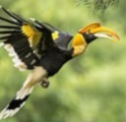

#### ****Arunachal Pradesh****

##### Go to Mechuka, camp there and visit the Ziro Festival

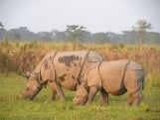

#### ****Assam****

##### Explore the Brahmaputra river, Enjoy Kaziranga Wildlife Safari, the One Horn Rihno

#### ****North-India****

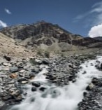

#### ****Ladakh****

Visit Leh go for a bike trip and a camp fire

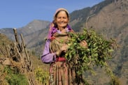

#### ****Himachal Pradesh****

##### Go for a Rafting , Para Gliding and

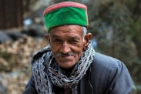

#### ****Uttarakhand****

##### Write and publish blog posts, share your thoughts.

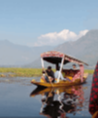

#### ****Kashmir****

# About us :We are an AI based and tracking platform 2024, who provides only the Activities during your Travel nd Leisure. We have track and friends with all the local/sole activity providers across the regions of India. We are confined to some of the regions now, but growing day by day remarkably. Hand over your activity issues to us and we will book it prior with confirmation. While you take care of your hotel, flight, taxi etc ...... We will take care of your ACTIVITIES* **Leisure Activities**

Note slab:

We Book Activities with Confirmation! Relax ! And we will do the rest for our good visitors... Note: Booking will be confirmed only with an Advanced Payment (No Negotiation) Your Behavior is your Character